Open Access
ORIGINAL ARTICLE
Full Length Article


A Formal Approach to Verify Decision Rules in Educational Data Mining Using Coloured Petri Nets
Muhammad Nauman¹, Nadeem Akhtar²
^{1, 2} Department of Computer Science and IT, The Islamia University of Bahawalpur, Bahawalpur 63100, Pakistan

ABSTRACT
Education is one of the prominent factors for the progress of society. With the use of modern software technologies, the higher educational institutes are recording and saving large amounts of a student’s educational data. The use of educational data mining techniques can support better decision making for higher educational institutes. Hence, there is an immense need to analyze educational datasets to improve decision making. This paper presents an approach to mine and formally verifies the decision rules using educational data mining. The decision tree algorithm is the best choice for mining educational datasets to discover classification decision rules. The first objective of the proposed approach is to improve the higher education decision making using data mining. The second objective of the research is to provide correctness guarantees of discovered decision rules using formal verification. The correctness of the decision rules is guaranteed using Coloured Petri nets (CP-Nets). The use of model checking formalism in the proposed approach ensured the decision rules correctness. The empirical results demonstrate the improved correctness by integrating formal verification with 98.68% accuracy for classification results for six departments. This research work contributes to enhance higher education decision making and improve the learning activities and administration of higher educational institutes.
Keywords: Formal approaches, educational data mining, decision trees, formal verification, model checking, Coloured Petri nets
Author`s Contribution  ¹ Data analysis, Data collection, conception, interpretation and manuscript writing  ² Conception, synthesis, and manuscript writing  ^{3.}Conception, Interpretation and discussion | Address of Correspondence  Muhammad Nauman  Email: nauman@iub.edu.pk | Article info.  Received:  Accepted:

Cite this article: M. Nauman, N. Akhtar. A Formal Approach to Verify Decision Rules in Educational Data Mining Using Coloured Petri Nets.
Funding Source: Nil
Conflict of Interest: Nil

Introduction

Education is one of the prominent factors and plays a fundamental role in the progress of society. Higher educational decision making is crucial for better learning activities. The educational data mining identifies problem areas in educational learning activities faced by students and institutes. Data mining is a process of gaining useful insights and unknown patterns from large data sets. With the advancement in software development and their use in the education sector, the university departments are recording and saving large amounts of a student’s educational data. This educational data consists of a student’s academic records, class activities, assignments, and quizzes. There is an immense need to analyze this data to improve decision making³⁸ ³ ³³ ³⁶. The educational data analysis helps in improving the quality of education, increase in student performance, improved career counseling, resulting in a state of the art education system.
The decision tree algorithm is the best candidate to mine educational data to extract decision rules from large datasets. A decision tree ⁴⁴ ⁴² is a mathematical decision support tool that represents the decisions in a tree structure. In literature, the decision tree investigated in the educational data mining³⁷ ⁵⁶ medical⁵⁸, internet of things⁵, electrical systems monitoring¹¹, sentiment analysis⁴⁶, and hadith classification². In many cases, it has extended to deal with data uncertainty⁵⁴.
The predictive classification models have been prone to errors²⁷ ⁴⁹. Formal verification is the process of proving the correctness, safety, and liveness properties of complex software and hardware systems. Hence, Formal verification is the best candidate to model, verify, and validate these models50. The formal verification of the predictive classification models is the best option to provide a correct- ness guarantee. Formal verification can also be applied to verify the correctness of classification decision rules derived from large amounts of data. The use of formalism allows more rigorous decision rules since formal models have a solid mathematical background to guarantee the correctness of these rules.
Coloured Petri nets²⁵ is a type of Petri nets⁴⁰ used in modeling of systems that contain discrete, concurrent, and scattered events and have strong mathematical logic associated with Standard ML (SML)³⁵ programming language. They are useful in modeling both non-deterministic and stochastic processes and allow a systematically exhaustive exploration of the mathematical model to prove, disprove, and guarantee the correctness.
The main contributions of this research work are:
- A novel formal data mining approach to analyze educational data to support better decision making for higher educational institutes.
- Use of formal verification to verify the correctness of binary classification decision rules extracted from decision tree classification models.
- Use of model checking formalism to formally verify the correctness of the data mining process outcomes.

The rest of this paper is organized as in Section 2 discussed background, the literature review discussed in section 3, section 4 discusses the research methodology, and the conclusion presented in section 5.

Background

2.1 Formal Verification and Model Checking
Formal verification is the process of proving the correctness, safety, and liveness properties of complex software and hardware systems. Model checking¹⁵ ¹⁴ ¹³ is a formal verification technique based on formal methods for software and hardware verification. It can mathematically model the system behavioral-properties in terms of state-transitions to guarantee the correctness of the system. The developed the mathematical model of the system under consideration used for a comprehensive review. The model checking and formal specification of a sys- tem requirement increase the quality of the system. In the model checking process, complete possible states and execution paths inspected exhaustively to validate if the specific property holds.

2.2 Decision Tree
A decision tree is a mathematical decision support tool that represents the decisions in a tree structure. It builds a top-down model to classify instances of the given dataset. A decision tree model trained on the dataset is used to predict classification labels and categorize objects present in the dataset¹⁰.
There is a root node in the decision tree at the top and leaf nodes at the bottom. The outgoing edges from the root represent different possibilities and outcomes. The internal nodes represent the test on attributes while the edges represent the result of the test. In the last stage, leaf nodes represent the predicted outcome of internal node selections⁴⁷.
There are two stages in the decision tree construction process. The first stage of the process consists of decision tree training. In the second stage, the trained decision tree from the previous step pruned. The decision tree building process performed in a top-down order. During the tree building process, the recursion method used to partition the tree to put object instances of a similar nature to a single class label.

2.3 WEKA
The Waikato Environment for Knowledge Analysis (WEKA)¹⁹ is a tool that contains a set of machine learning algorithms written in Java for data mining research. It contains several tools and algorithms for predictive modeling, data analysis, and visualizations. The WEKA tool receives input in several formats. It has an easy graphical user interface for inputs and result visualizations. In this work, the dataset in CSV format is loaded into WEKA to train the decision tree model. The J48 is an enhancement to the ID3 algorithm⁵⁵ and open-source implementation of the C4.5 algorithm⁴³.

2.4 Coloured Petri Nets (CP-Nets)
Coloured Petri Nets (CP-Nets) are used in the modeling of systems that contain discrete, concurrent, and scattered events and have strong mathematical logic associated. They are useful in modeling both non-deterministic and stochastic processes and allow a systematically exhaustive exploration of the mathematical model to prove, disprove or analyze the correctness of various communication systems, operating systems, business processes, and re-engineering.
In CP-Nets untimed models are mostly used to reveal logical errors while timed nets for concurrent systems. Most importantly, CP- Nets allow modeling of both timed and untimed executable nets. CP-Nets support a strong mathematical foundation for state space and reachability analysis to verify numerous properties like bounded-ness, home, liveness, fairness, terminating, and cyclic. To overcome state explosion problems state space reduction methods are implemented through Linear- time temporal logic (LTL)¹² or Computation tree temporal logic (CTL)⁶. The CP-Nets comes with a graphical interface that makes it easy to use, under- stand, and user-friendly. The CPN-tools1 has a large community and is used in industrial projects as well as in research projects, has extensive documentation and support.
Table I: Comparison with other educational data mining approaches proposed in literature.
Author | Year | Algorithms | Dataset Size | No. of Features | Formally Verified
Nieto et al.37 | 2019 | Decision Trees, Logistic Regression, Random Forest | 6100 | 16 | No
Xu et al.56 | 2019 | Decision Trees, Artificial Neural Networks, Support Vector Machines | 4000 | 3 | No
Akram et al.4 | 2019 | ZeroR, OneR, ID3, J48 | 115 | 3 | No
Yao et al.57 | 2019 | Linear Regression | 15,801 | 19 | No
Migu´eis et al.34 | 2018 | Random Forest, Decision Trees, Support Vector Machines | 2500 | - | No
Kardan et al.30 | 2013 | Support Vector Regression, K- nearest Neighborhood, Decision Tree | 2373 | 8 | No
Jovanovic et al.29 | 2012 | AdaBoost, Bagging, J48, Linear Discriminant Analysis, Logistic Regression, Naive Bayes, Neural Net, Random Forests | 260 | 11 | No
Current study | - | Decision Trees, Model Checking | 4617 | 108 | Yes

2.5 Decision Tables
Decision Table⁵¹ is a tool that supports solving complex computational problems. The decision tables represent problems composed of conditions, rules, and actions. In these tables, conditions are variables that need evaluations to perform specific actions. These can be a single step or set of multiple situations that need to be chosen to depend upon the data in conditional variables.

Literature Review

3.1 Educational Data Mining
Educational data mining is the process of extracting useful information from educational datasets. Educational data mining has received tremendous attention from the research community in the last decades⁷ ³⁹ ²⁸ ²⁸ ²¹ ³⁶ ³² ¹⁷ ⁸ ²². The prime objective of the research is the prediction of grades, course selection, course recommendations, and drop out chances of students. In this research work, the dataset analyzed to classify an applicant admission rule to improve the institute decision making for better learning activities. The models predict whether the applicant has enough academic grades for being selected in a particular department or not. After training these classification models it also performs the formal verification of the classification models using the model checking. In this research work, departmental candidate selection rules are extracted using decision trees classification models and formally verified using CP-Nets. Table 1 shows the comparison with other educational data mining approaches proposed in the literature.
Y. Nieto et al.³⁷ discussed the management decision structure of higher educational institutes to support better governance using supervised data mining classification algorithms. The decision tree, logistic regression, and random forest supervised classification algorithms applied to the undergraduate engineering dataset. The results of the research compared using the ROC curve to demonstrate the outcome. Modeling student efforts and learning ability discussed the dynamics of real-world applications. A novel model proposed to address student’s efforts and learnability from a generative perspective by exploiting the temporal variations²⁰. Francis, B.K. et al.¹⁸ have proposed a hybrid predictive algorithm which uses both classification and clustering techniques to mine educational dataset for the evaluation of student performance in academia for higher educational institutes.
Migu´eis et al.³⁴ have proposed a two-stage predictive model for predicting the career path for students at the end of the final year. The dataset of 2459 students from 2003 to 2015 analyzed to confirm that the random forest outperforms the other supervised classification algorithms. Jia et al.²⁶ proposed the SMNaive Bayes model to overcome the problem of low accuracy faced by classification techniques to predict the student results. The developed model uses previous stage course performance to predict future performance. Roy et al.⁴⁵ has discussed the student academics and courses to identify their interested career areas. The research motive is to identify primer career paths for computer science students.

3.2 Formal verification of Neural Networks
The formal verification of neural networks has been explored extensively by the research community. Most of the work showed the usage of theorems proving for formal verification of the neural network⁴¹ ⁴⁸. Ivanov et al.²⁴ trained a non-linear neural network for formal verification of the safety properties. They transformed a sigmoid based neural network into an equivalent hybrid system. Their proposed method works on many practical examples. Huang et al.²³ proposed a formal verification methodology for the robustness of classification models. They used polyhedrons for capturing inter- mediate perturbation present in the neural network model.
Pulina and Tacchella⁴¹ used SMT solver for investigating the misclassification in the output layer. They discussed several adversarial examples with the pro- posed methodology. Katz et al.³¹ integrated the simplex method and SAT solver for formal verification of the deep neural networks. They verified the safety properties of airborne collision avoidance systems. Ehlers and Ruediger¹⁶ used an LP solver with a modified SAT solver used to verify neural network correctness. The method used a technique to approximate the network behavior to limit the search space. The methodology implemented us- ing two case studies having collision detection and digit recognition problems. In this research work, a similar verification problem is studied as discussed above for the neural networks.

Formal verification of Decision Trees
There is little research work present on decision tree formal verification. Tornblom et al.⁵³ proposed methodology to verify the safety property of decision tree ensemble models. The input and output patterns analyzed using the VoTE tool by discussing two case studies. In⁵² safety-critical properties of random forests are formally verified by partitioning the input space in disjoint sets for decision trees. The equivalence classes are computed from the random forest and verified against requirements.
Bastani et al.⁹ trained a neural network to play the game Pong. An equivalent decision tree was extracted from trained neural works as decision tree model verifications are much easier than neural net- works. The decision tree policies were formally verified by using an SMT solver. Our method uses CPN tools to model the decision rules derived from the decision tree model. The CPN tokens are passed through model transition paths to verify the correctness of decision rules.
Research Methodology

The proposed approach to formally verify the decision rules is shown in Fig.1. In this work, decision rules derived from decision tree models formally verified using CP-Nets. The approach has three steps, first training the decision tree classification models, second derived decision rules in the second stage, and in the third stage formally verifying the decision rules using CP-Nets. The rule ex- traction is performed manually from decision tree visualizations using WEKA.

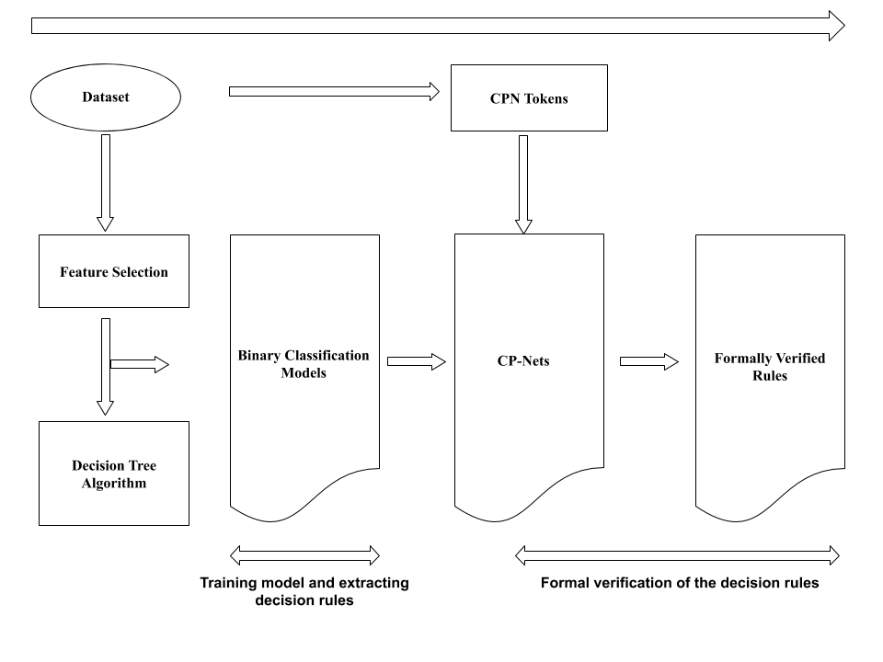
Fig. 1: The proposed research methodology to formally verify decision rules using Coloured Petri nets.

4.1. Data Collection
The dataset consists of the academic details of candidates for the semester spring 2018 at The Islamia University of Bahawalpur. The predictive classification models trained with the training dataset of candidates seeking admission in the eight departments. The data exported in CSV format from the online admission system of The Islamia University Bahawalpur. The dataset contained 4617 records with 108 features. The goal is to find the decision rules that classify an applicant as a “Yes” or “No” label. The attribute ”Yes” represents the classification label for those candidates who were offered ad- mission in a particular department while ”No” rep- resents the label for the not offered scenario. The decision tree model is trained to derive binary classification rules. The decision tree is chosen because of organized structure and better rule visualizations support of data splits points. The decision tree in Fig.2 is gained using WEKA graphical user interface for the department of computer science applicant academic details dataset.

4.2. Feature Selection
Finding the most correlated attributes to the final class label and how much they affect the classification is very crucial. Significantly, this stage shows the average correlation of the prominent features for the prediction class. Data fields with high correlation considered as recommendation points for students and academic staff.
Pearson correlation coefficient algorithm is used to select the related features shown in Table 2. The Institute offers
Table III: Dataset used to train decision tree binary classification models
Domicile | SSC | Admission Test | Terminal Degree | Optional 1 | Optional 3 | Document Verified
Bahawalpur | 953 | 0 | 843 | 177 | 162 | Yes
Bahawalpur | 850 | 51 | 821 | 136 | 141 | No
OPEN | 860 | 0 | 783 | 131 | 158 | No
OPEN | 963 | 53 | 914 | 189 | 172 | Yes
Bahawalpur | 919 | 0 | 872 | 171 | 167 | Yes
Bahawalpur | 738 | 54 | 726 | 118 | 102 | No
admission in two quota systems Open merit and Bahawalpur merit. The university also conducts admission tests for specific departments where it receives a large number of applications.
Table II: Data set selected features using Pearson correlation coefficient.
Feature Name | Feature Description
Domicile | Domicile Quota for the Candidate, The domicile represents the city of the candidate residency.
SSC | SSC represents the candidate 10th grade score.
Admission-Test | Admission Test represents the grades obtained by candidates in the admission test conducted.
Terminal-Degree | Terminal Degree represents the grades obtained by candidates in the relevant degree required for admission in an offered program.
Option 1 | Option 1 represents the grades of optional subjects.
Option 3 | Option 3 represents the grades of optional subjects
Document Verified | Document Verified represents the weather the candidate is appeared in document verification process.

4.3. Decision Tree Model
The J48 algorithm is applied to train a binary classification model with a ten-fold cross-validation procedure. The WEKA graphical interface is used to visualize the decision tree. It is selected because it has a graphical interface and is very easy to use and convenient to load and process the data set. It’s easy to apply classification algorithms to train a predictive model and visualize it. It also offers stability among precision, speed, and result interpretations. Table 4 shows the set of rules derived from the trained decision tree models.

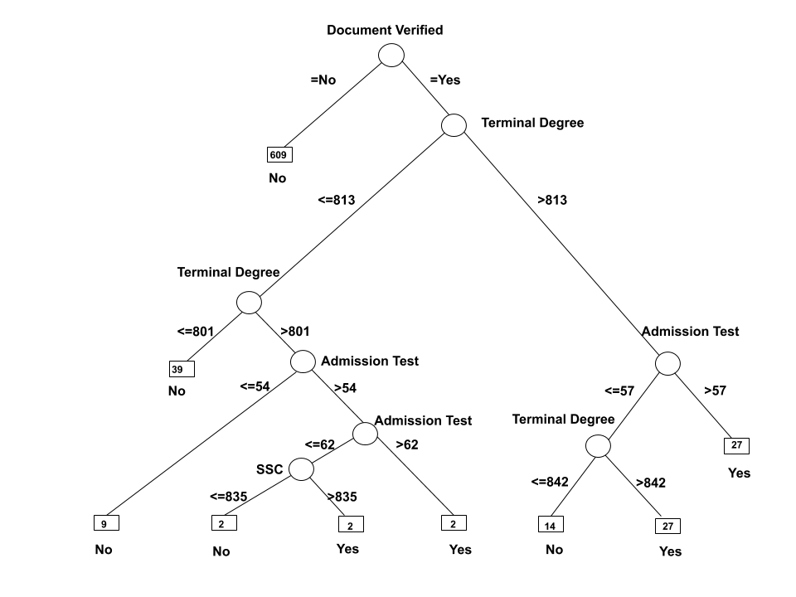
Fig. 2: Decision tree showing the binary classification results for the computer science department.

Table IV: Decision rules extracted from decision tree for computer science department shown in Fig.2.
Rule | Rule Description
R1 | IF Document-Verification > 0 AND Terminal-Degree > 813 AND Admission-Test > 57 THEN Decision = Yes
R2 | IF Document-Verification > 0 AND Terminal-Degree > 842 AND Admission-Test < 57 THEN Decision = Yes
R3 | IF Document-Verification > 0 AND Terminal-Degree < 801 THEN Decision = No
R4 | IF Document-Verification > 0 AND Terminal-Degree =< 813 AND Admission-Test > 62 THEN Decision = Yes
R5 | IF Document-Verification =< 0 AND Admission-Test < 40 THEN Decision = No
R6 | IF Document-Verification =< 0 THEN Decision = No

4.4. Performance metrics
Predictions made by a decision tree rules labeled as “Yes” or “No”. Here “Yes” represents the candidate offered admission for a particular department while “No” shows the applicant never selected for the specific department. The predictive classification model performance evaluated by measuring different parameters including the number of True Positives(TP), True Negatives (TN), False Positives (FP), and False Negatives (FN) where the total number of instances is represented as N and computed such as:

N = TP+TN+FP+FN (1)

Accuracy (ACC): ACC specifies the accuracy of the classification model such that:

ACC = (TP+TN)/N (2)

Precision (P): P specifies the number of positive instances correctly identified from all positively predicted instances such as:

P = TP / (TP+FP) (3)
Recall(R): R specifies the number of positive in- stances identified from all positive instances such as:

R = TN/ (TN+FN) (4)

Sensitivity (TPR): TPR specifies the correctly classification rate of positive instances such as:

TNR = TP/(TP+FN) (5)

Specificity (TNR): TNR specifies the correctly classification rate of negative instances such as:

TNR = TN/ (TN+FP) (6)

Area under the ROC curve (AUC): ROC curve graphically displays the performance of the predictive model by plotting true positive and false negative rates for all possible values. The area under the curve shows the overall performance of a classification model. The perfect prediction value for AUC is 1.0 and 0.5 corresponds to the diagonal on the ROC curve.

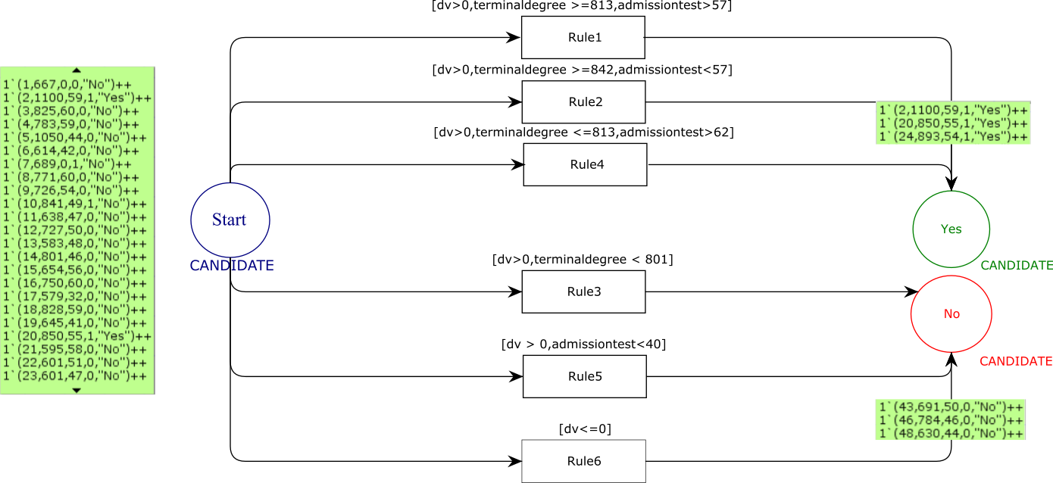
Fig. 3: Coloured Petri nets model equivalent of decision rules shown in Table 4.

Table V: Definition of color sets
Color Set | Definition
colset NO = INT; | Specifies the serial number for candidate
closet DV = INT; | Specifies the document verification status of the candidate.
colset TD = INT; | Specifies the terminal degree grades obtained by the candidate
colset AT = INT; | Specifies the admission test marks obtained by the candidate
colset L = string; | Specifies the applicant classification label.
colset CANDIDATE = product NO*TD *AT*DV*L; | Cartesian product specifies the candidate attributes present in selected feature list.

4.5. Formal Verification of Decision Rules
The Fig.3 shows derived six decision rules from Table 4 to construct a Coloured Petri Nets model for the dataset of applicants from the computer science department. These rules are grouped hierarchically for better understanding and model visualization. The execution of rules depends on the sequence of decisions made by the CPN tokens in the model. The model consists of three transition places and a set of tokens constructed using the applicant’s dataset for the spring semester 2018. The model simulated using the simulation tool available in the CPN tool graphical user interface. Table 5 shows the color set definitions used to transform decision rules into the CP-Nets model. The simulations tools simulate 50 tokens at a time. The CPN tokens created to rep- resent the applicant’s academic details in the model shown in Table 6.
The transition places represent the applicant’s status in the CPN model. The transition places are named as “candidate” in the CP-Nets model. The model simulations begin at the first transition state called the initial state. The single transitions in the model represent a single decision rule. In the first step, the model is loaded for execution with all to- kens at the initial place. In the second step, the to- kens pass through the transition places by initiating the simulation process. The transition places pass only the tokens that verify the transition condition in the CP-Nets model. In the third stage, the CP- Nets model simulates the tokens representing the applicant’s academic details to the transition places “Yes” or “No”. The transition place “Yes” or “No” in the model is reached by traversing through decision rules.
The decision rules formally verified by simulating all tokens having applicant’s academic details through the transition places and inspecting the “Yes” and “No” transition places in the model. The transition places “Yes” states that the candidate is offered admission in the department while the transition place “No” states the not offered scenario for a particular applicant. Table 7 shows the revised rules with remarks after performing the decision rules for- mal verification. The remarks column shows the rules revisions status in the model. In Fig.4, the transition place represents the revised rules obtained from the formal verification process. Fig.5 shows the confusion matrix performance evaluation before and after the formal verification process. It is observed from the confusion matrix that a correct classified instance has improved by applying the formal verification to the decision tree models.

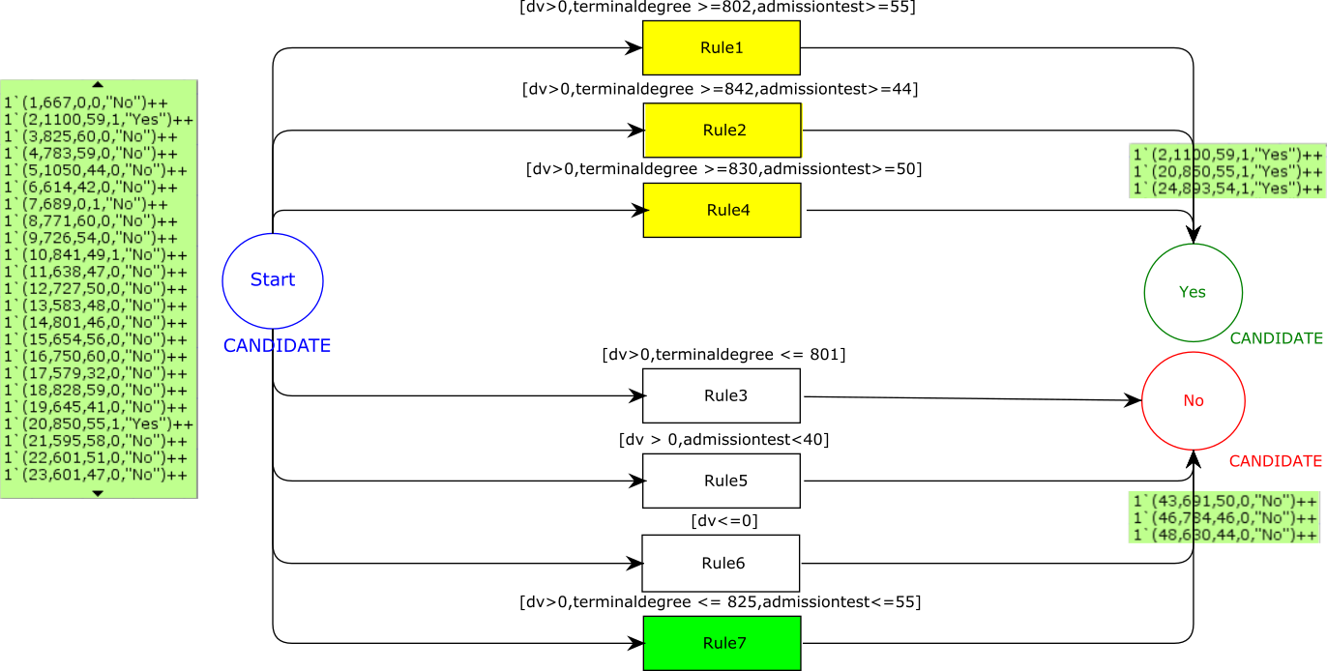
Fig. 4: Color Petri nets model of formally verified decision rules shown in Table 7.

Table VI: Computer science CPN tokens classification labels before and after formal verification(FV)
CPN Token | Actual Label | Predictive Labels
 |  | Before FV | After FV
1‘(1,667,0,0,”No”)++ | No | No | No
1‘(2,1100,59,1,”Yes”)++ | Yes | Yes | Yes
1‘(47,829,56,1,”No”)++ | No | Yes | No
1‘(10,841,49,1,”No”)++ | No | Yes | Yes

4.6. What-if Analysis
What-if-analysis is used to structure the scenario cases as “what will happen to the solution if an input value is changed?” In the current dataset analysis, the prominent variables for what- if-analysis are shown in Table 2. It is observed from the first decision rule in Table 7 that applicants who have marks greater than 802 out of 1100 in the terminal degree with admission test mark greater than 55 are classified with the label “Yes” for the computer science department. The second decision rule states that an applicant needed 842 marks in the terminal degree with admission test marks greater than 44 out of 100. The third rule states that if an applicant has less than 801 marks they are not offered the admission. The fourth rule states that if they have scored greater than 50 marks in the admission test then they need greater than 830 marks in the terminal degree to have a strong chance to be selected in the computer science department. It is observed from rule 6 that document verification is a very crucial part of the admission process and if any applicant has not verified their original academic documents they are not offered admission in the department. Rule 5 states that if an applicant has less than 40 marks in the admission test then they are not offered the admission. It
is observed from rule 7 that if an applicant has less than 825 marks in the terminal degree and less than 55 in the admission test then there is no chance of selection in the computer science department.
Table VII: Revised decision rules after performing formal verification of decision rules for the computer science department.
Rule | Rule Description
R1 | IF Document-Verification > 0 AND Terminal-Degree >= 802 AND Admission-Test >= 55 THEN Decision = Yes
R2 | IF Document-Verification > 0 AND Terminal-Degree >=842 AND Admission-Test >= 44 THEN Decision = Yes
R3 | IF Document-Verification > 0 AND Terminal-Degree =< 801 THEN Decision = No
R4 | IF Document-Verification > 0 AND Terminal-Degree >= 830 AND Admission-Test >= 50 THEN Decision = Yes
R5 | IF Document-Verification > 0 AND Admission-Test < 40 THEN Decision = No
R6 | IF Document-Verification =< 0 THEN Decision = No
R7 | IF Document-Verification > 0 AND Terminal-Degree =< 825 AND Admission-Test =< 55 THEN Decision = No

4.7. Pseudo-code algorithm description
The formal verification algorithm starts with Input and Output descriptions. The Input for the algorithm consists of CP-Nets and CPN tokens. The variable CP-Nets represents the derived decision rules modeled in Coloured Petri nets. The variable CPN token contains the structure of the token used for formally verifying the CP-Nets model. This algorithm contains two loops that iterate through to simulate all tokens through all 6 rule transitions present in the CP-Nets model (see lines 1-17). The transitions in CP-Nets models abstractly model the decision rules. In the loop body, the first IF Else statement checks if the token simulated to transition states “Yes” or “No” in the model. The first IF statement checks the token actual classification label against the predicted label. If actual and predicted labels are ”Yes” then the token simulates to a transition state “Yes” and the decision rule is marked formally verified. If the token actual prediction label is “No” and the transition label is ”Yes” then the decision rule needs revisions(see line 7). In that case, the routine ReviseRule called to perform revision operations to revise transition rules for the next version of CP-Nets model.
The ReviseRule receives the rule set and the token being simulated for formal verification. The token is again simulated through the model with revised rules to validate the actual and predicted labels. The rule set contains all the rules in the CP- Nets model and the token contains academic details. All rules are revised sequentially to simulate the token through the model to reach a transition state with the desired predictive token label (see lines 18-32). The revised rule routine contains the two for loops to mathematically adjust decision rules attributes in the CP-Nets model. The rule revision subroutine per- forms mathematical operations to adjust the rule at- tributes by incrementing or decrementing the value by 10(see lines 22 and 24). The integer value 10 is chosen because the rule revising routine might not go out of bounds for other tokens. In the case of the revised routine call, a new version CP-Nets model is constructed to pass all the tokens from the revised model to execute the formal verification algorithm again.
This process continues until all the rules are adjusted to pass the maximum token from the CP- Nets model. The final version of the CP-Nets models represents the formally verified decision rules for higher education institutes decision making.

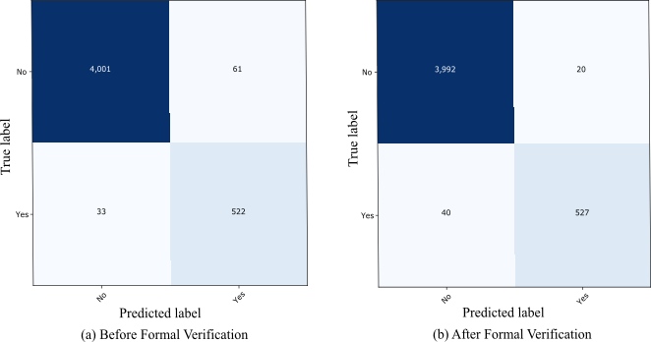
Fig. 5: Confusion Matrix of binary classification model before and after formal verification.

4.8. Results
The result set contained the applicant’s data from six departments of the Islamia University Bahawalpur. Table 3 shows a few instances of applicant’s data exported from the university admission system. The decision tree model is trained using the J48 algorithm and shown in Fig.2. The decision tree is visualized using WEKA Tool, the decision rules are extracted manually by analyzing the leaves and edges of the tree and shown in Table 4. These decision rules represent the scenarios of selection criteria for the applicants in respective departments. The derived rules transformed into CP-Nets transition rules. The color set constructs definitions for extracted rules are shown in Table 5. The CP-Nets model design of extracted decision rules from decision tree models shown in Fig.3. The CPN tokens are used to formally verify the decision rules constructed using the data set used for training the decision tree shown in Table 6. The remarks column shows whether the token is passed from the decision rule to formally verify the correctness of the rule or the decision rules needs corrections. The revised CP-Nets model after executing with tokens with decision rules analyses and revised rules are shown in Fig.4. The revised rules and newly added rules
After performing formal verification using CP-Nets model analyses are shown in Table 7. The algorithmic steps used for decision rules analyses and revisions are shown in Algorithm 1.
It is observed that the decision of the university administration to verify the original documents as shown in Fig.2 is a bottleneck in the admission process because 609 are not able to complete the verification process in the computer science department only. Hence the institute needs a revised policy for document verification. These academic details can be used by higher educational institutes to monitor the academic background of students in various pro- grams to improve the learning activities. Table 7 shows the performance evaluation results obtained by formally verifying the six department applicant’s data using the proposed approach. Fig.6 shows the ROC curve to evaluate the performance of the proposed approach for all departments under discussion. The ROC curve in green represents the performance evaluations before formal verification and the red color curve represents the performance evaluation after formal verification is performed on decision rules.

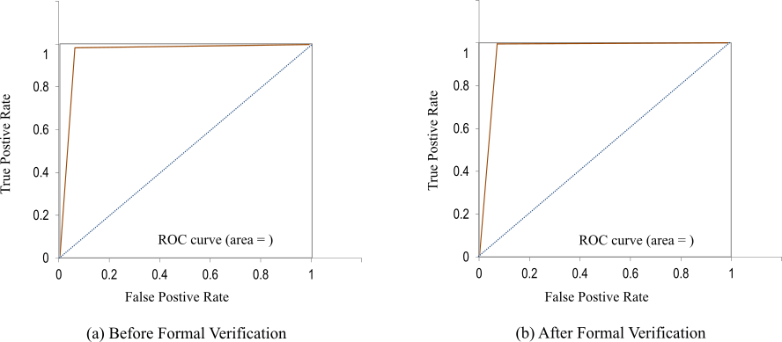
Fig. 6: ROC curves of departments before and after formal verification.

4.9. Discussion
The decision tree-based model accuracy for educational data mining is over 90% shown in Table 9 for six different departments. Hence, it concluded that the tree base models are a good choice for educational data mining. It is observed that formal verification enhances the decision tree model performance. Our decision tree model outperforms the decision tree models proposed in³⁷ ⁵⁶ ¹⁸ ³⁴.
Tree based models implemented in the educational decision support system enhances the quality of learning. When used for administrative decision support, our models can provide a simulation tool to explore various scenarios and identify rules and bottleneck in the admission process.
It is important to state that the results of this study may not generalize on a larger scale as they may be affected by institutional bias, and therefore further work comparing the results on extended datasets from other institutes would be beneficial. Despite this limitation, the achieved outcomes remain significant to the area of educational data mining.
The results of this research study provide insights for enhancing and revising the administration decision making. To our best knowledge, this study is the only work aimed at developing decision tree models and guaranteeing the correctness of decision rules using formal verification.

Table VIII: Decision tree binary classification models performance analysis before and after performing formal verification
Department Name | Before Formal Verification |  |  |  | After Formal Verification
Domicile | Sp | Sn | ACC | AUC | Sp | Sn | ACC | AUC
Computer Science | 86.44 | 98.36 | 97.40 | 0.92 | 162 |  |  | Yes
Agriculture | 98.03 | 93 | 94.95 | 0.95 | 141 |  |  | No
Biochemistry & Biotechnology | 98.38 | 99.63 | 99.54 | 0.99 | 158 |  |  | No
Chemistry | 83.01 | 99.01 | 98.13 | 0.91 | 172 |  |  | Yes
Physics | 92.42 | 99.29 | 98.58 | 0.95 | 167 |  |  | Yes
English | 91.80 | 99.12 | 98.52 | 0.95 | 102 |  |  | No
Complete Dataset | 94.05 | 98.50 | 97.96 | 0.96

Conclusion

The use of data mining techniques to analyze educational data can support better decision making for higher educational institutes. It can facilitate in unveiling hidden decision rules present in the large amounts of educational data stored at higher educational institutes. The derived decision rules have been prone to errors, to guarantee the correctness of these rules; formal verification plays an important role. Formal verification is a formal technique used for guaranteeing the correctness of complex systems.
In this work, an approach to formally verify classification decision rules is proposed. The classification models are formally verified by modeling decision rules as CP-Nets models. The objective of this research work is to derive decision rules and provide correctness guarantees of decision rules. This objective is attained by integrating formal verification in the predictive classification process. The decision tree algorithm is used to train classification models using WEKA tools. The rule derivation is performed to obtain decision rules from decision tree visualizations. The derived rules transformed into CP-Nets models. The CP-Nets models were executed with CPN tokens containing validation applicant academic detail data to formally verify the correctness of the classification model. The research results evaluation showed that the pro- posed approach enhanced the classification model performing by using formal verification. Therefore, from this research work, it is concluded that extracted decision rules using data mining can be formally verified using formal verification to guarantee the correctness of the rules. In this work, only the J48 decision tree algorithm was explored with CPN tools. The proposed approach has limitations and needs further investigation. First, the dataset only contained applicant’s details of six departments from one higher educational institute, for the generalized results the proposed methodology needs to be validated with a large number of higher educational institute’s datasets. Second, the proposed approach used only the J48 decision tree algorithm using other machine learning methods may lead to better accuracy. Third, manually extracting and revising decision rules needs to be automated to apply this approach to the large datasets. In the future, we plan to investigate more data mining techniques and machine learning algorithms. In this work, only model checking with CP-Nets is explored, in future other formal verification techniques like theorem proving needed to be investigated for performance improvement of the verification process of decision rules.

References
1. Cpn tool - http://www.cs.au.dk/cpntools.
2. Hammam M Abdelaal, Berihan R Elemary, and Hassan A Youness. Classification of hadith according to its content based on supervised learning algorithms. IEEE Access, 7:152379–152387, 2019.
3. Yuri Vanessa Nieto Acevedo, Carlos Enrique Mon- tengro Mar´ın, Paulo Alonso Gaona Garcia, and Rub´en Gonzalez Crespo. A proposal to a decision support system with learning analytics. In 2018 IEEE Global Engineering Education Conference (EDUCON), pages 161–168. IEEE, 2018.
4. Aftab Akram, Chengzhou Fu, Yuyao Li, Muhammad Yaqoob Javed, Ronghua Lin, Yuncheng Jiang, and Yong Tang. Predicting students’ academic procrastination in blended learning course using homework submission data. IEEE Access, 7:102487– 102498, 2019.
5. Nusaybah Alghanmi, Reem Alotaibi, and Seyed M Buhari. Hlmcc: A hybrid learning anomaly detection model for unlabeled data in internet of things. IEEE Access, 7:179492–179504, 2019.
6. Christel Baier and Joost-Pieter Katoen. Principles of model checking. MIT press, 2008.
7. D. Baneres, M. E. Rodr´ıguez-Gonzalez, and M. Serra. An early feedback prediction system for learners atrisk within a first-year higher education course. IEEE Transactions on Learning Technologies, 12(2):249– 263, April 2019.
8. Thiago Medeiros Barros, Ivanovitch Silva, and Luiz Affonso Guedes. Determination of dropout student profile based on correspondence analysis technique. IEEE Latin America Transactions, 17(09):1517–1523, 2019.
9. Osbert Bastani, Yewen Pu, and Armando SolarLezama. Verifiable reinforcement learning via policy extraction. 2018.
10. Neeraj Bhargava, Girja Sharma, Ritu Bhargava, and Manish Mathuria. Decision tree analysis on j48 algorithm for data mining. Proceedings of International Journal of Advanced Research in Computer Science and Software Engineering, 3(6), 2013.
11. Chien-Kuo Chang, Chang-Sing Lai, and Ruay-Nan Wu. Decision tree rules for insulation condition assessment of pre-molded power cable joints with arti- ficial defects. IEEE Transactions on Dielectrics and Electrical Insulation, 26(5):1636–1644, 2019.
12. Edmund M Clarke and E Allen Emerson. Design and synthesis of synchronization skeletons using branching time temporal logic. In Workshop on Logic ofPro- grams, pages 52–71. 1981.
13. Edmund M Clarke, Thomas A Henzinger, and Helmut Veith. Introduction to model checking. In Handbook ofModel Checking, pages 1–26. Springer, 2018.
14. Edmund M Clarke, Thomas A Henzinger, Helmut Veith, and Roderick Bloem. Handbook of model checking, volume 10. Springer, 2018.
15. Edmund M Clarke Jr, Orna Grumberg, Daniel Kroening, Doron Peled, and Helmut Veith. Model checking. MIT press, 2018.
16. Ruediger Ehlers. Formal verification of piece-wise linear feed-forward neural networks. 2017.
17. Eduardo Fernandes, Maristela Holanda, Marcio Vic- torino, and Borges. Educational data mining: Predictive analysis of academic performance of public school students in the capital of brazil. Journal of Business Research, 94:335–343, 2019.
18. Bindhia K Francis and Suvanam Sasidhar Babu. Predicting academic performance of students using a hybrid data mining approach. Journal of medical systems, 43(6):162, 2019.
19. E Frank, MA Hall, and IH Witten. The weka workbench. online appendix for data mining: Practical machine learning tools and techniques, 2016.
20. Lina Gao, Zhongying Zhao, Liang Qi, Yongquan Liang, and Junwei Du. Modeling the effort and learning ability of students in moocs. IEEE Access, 7:128035–128042, 2019.
21. Quan Guo, Minghua Chen, Du An, Linlei Ye, et al. Prediction ofStudents’ Course Failure Based on Campus Card Data, pages 361–364. 2019.
22. Ling Huang, Chang-Dong Wang, Hong-Yang Chao, Jian-Huang Lai, and S Yu Philip. A score prediction approach for optional course recommendation via cross-user-domain collaborative filtering. IEEE Access, 7:19550–19563, 2019.
23. Xiaowei Huang, Marta Kwiatkowska, Sen Wang, and Min Wu. Safety verification ofdeep neural networks. 2017.
24. Radoslav Ivanov, James Weimer, Rajeev Alur, George J Pappas, and Insup Lee. Verisig: verifying safety properties of hybrid systems with neural network controllers. 2019.
25. Kurt Jensen. Coloured Petri nets: basic concepts, analysis methods and practical use, volume 1. Springer Science & Business Media, 2013.
25. Kurt Jensen. Coloured Petri nets: basic concepts, analysis methods and practical use, volume 1. Springer Science & Business Media, 2013.
26. Baoting Jia, Ke Niu, Xia Hou, Ning Li, Xueping Peng, Peipei Gu, and Ran Jia. Prediction for Student Academic Performance Using SMNaive Bayes Model, pages 712–725. 2019.
27. Heinrich Jiang and Ofir Nachum. Identifying and correcting label bias in machine learning. arXiv preprint arXiv:1901.04966, 2019.
28. Fernando Jimenez, Alessia Paoletti, Gracia Sanchez, and Guido Sciavicco. Predicting the risk of aca- demic dropout with temporal multi-objective optimization. IEEE Transactions on Learning Technolo- gies, 12(2):225–236, 2019.
29. Milos Jovanovic, Milan Vukicevic, Milos Milovanovic, and Miroslav Minovic. Using data mining on student behavior and cognitive style data for improving e-learning systems: a case study. International Journal ofComputational Intelligence Systems, 5(3):597–610, 2012.
30. Ahmad A Kardan and Hamid Sadeghi. A decision support system for course offering in online higher education institutes. International Journal ofComputational Intelligence Systems, 6(5):928–942, 2013.
31. Guy Katz, Clark Barrett, David L Dill, Kyle Julian, and Mykel J Kochenderfer. Reluplex: An efficient SMT solver for verifying deep neural networks. 2017.
32. X. Li, X. Fan, X. Qu, G. Sun, C. Yang, B. Zuo, and Z. Liao. Curriculum reform in big data education at applied technical colleges and universities in china. IEEE Access, 7:125511–125521, 2019.
33. Jorge Maldonado-Mahauad, Isabel Hilliger, Tinne De Laet, Martijn Millecamp, Katrien Verbert, Xavier Ochoa, and Mar P´erez-Sanagust´ın. The lala project: Building capacity to use learning analytics to improve higher education in latin america. In companion pro- ceedings ofthe 8th international learning analytics & knowledge conference, pages 630–637, 2018.
34. Vera L Migu´eis, Ana Freitas, Paulo JV Garcia, and Andr´e Silva. Early segmentation of students according to their academic performance: A predictive modelling approach. Decision Support Systems, 115:36– 51, 2018.
35. Robin Milner, Mads Tofte, Robert Harper, and David MacQueen. The definition of standard ML: revised. MIT press, 1997.
36. Sreˇcko Natek and Moti Zwilling. Student data mining solution–knowledge management system related to higher education institutions. Expert systems with applications, 41(14):6400–6407, 2014.
37. Yuri Nieto, Vicente Gac´ıa-D´ıaz, Carlos Montenegro, Claudio Camilo Gonz´alez, and Rub´en Gonz´alez Crespo. Usage of machine learning for strategic decision making at higher educational institutions. IEEE Access, 7:75007–75017, 2019.
38. Yuri Nieto, Vicente Garc´ıa-D´ıaz, Carlos Montenegro, and Rub´en Gonz´alez Crespo. Supporting academic decision making at higher educational institutions using machine learning-based algorithms. Soft Computing, 23(12):4145–4153, 2019.
39. Paola Perchinunno, Massimo Bilancia, and Domenico Vitale. A statistical analysis of factors affecting higher education dropouts. Social Indicators Research, pages 1–22, 2019.
40. Carl Adam Petri. Kommunikation mit automaten. 1962.
41. Luca Pulina and Armando Tacchella. Challenging smt solvers to verify neural networks. Ai Communications, 25(2):117–135, 2012.
42. J. Ross Quinlan. Induction of decision trees. Machine learning, 1(1):81–106, 1986.
43. J Ross Quinlan. C4. 5: programs for machine learn- ing. Elsevier, 2014.
44. John R Quinlan et al. Learning with continuous classes, volume 92. 1992.
45. K Sripath Roy, K Roopkanth, V Uday Teja, V Bhavana, and J Priyanka. Student career prediction usinging advanced machine learning techniques [j]. International Journal of Engineering and Technology, 7(2.20), 2018.
46. Shihab Elbagir Saad and Jing Yang. Twitter sentiment analysis based on ordinal regression. IEEE Access, 7:163677–163685, 2019.
47. Steven L Salzberg. C4. 5: Programs for machine learning by j. ross quinlan. morgan kaufmann publishers, inc., 1993, 1994.
48. Karsten Scheibler, Leonore Winterer, Ralf Wimmer, and Bernd Becker. Towards Verification of Artificial Neural Networks. 2015.
49. David Sculley, Gary Holt, Daniel Golovin, Eugene Davydov, Todd Phillips, Dietmar Ebner, Vinay Chaudhary, Michael Young, Jean-Francois Crespo, and Dan Dennison. Hidden technical debt in machine learning systems. In Advances in neural information processing systems, pages 2503–2511, 2015.
50. Brian J Taylor and Marjorie A Darrah. Rule extraction as a formal method for the verification and validation ofneural networks, volume 5. 2005.
51. Angela Hum TCHEMRA. Tabela de decis˜ao adaptativa na tomada de decis˜oes multicrit´erio. 172 p. PhD thesis, Tese (Doutorado)-Escola Polit´ecnica da Universidade de S˜ao Paulo . . . , S˜a Paulo, Brazil, 2009.
52. John T¨ornblom and Simin Nadjm-Tehrani. Formal verification of random forests in safety-critical applications. 2018.
53. John T¨ornblom and Simin Nadjm-Tehrani. Formal verification of input-output mappings of tree ensembles. Science of Computer Programming, page 102450, 2020.
54. Smith Tsang, Ben Kao, Kevin Y Yip, Wai-Shing Ho, and Sau Dan Lee. Decision trees for uncertain data. IEEE transactions on knowledge and data engineering, 23(1):64–78, 2009.
55. Ian H Witten and Eibe Frank. Data mining: practical machine learning tools and techniques with java implementations. Acm Sigmod Record, 31(1):76–77, 2002.
56. Xing Xu, Jianzhong Wang, Hao Peng, and Ruilin Wu. Prediction of academic performance associated with internet usage behaviors using machine learning algorithms. Computers in Human Behavior, 98:166–173, 2019.
57. Yuan Yao, Zhenping Zhang, Hongyan Cui, Tao Ren, and Jinghua Xiao. The influence of student abilities and high school on student growth: A case study of chinese national college entrance exam. IEEE Access, 7:148254–148264, 2019.
58. Bing Zhang, Jiadong Ren, Yongqiang Cheng, Bing Wang, and ZhiyaoWei. Health data driven on continuous blood pressure prediction based on gradient boosting decision tree algorithm. IEEE Access, 7:32423– 32433, 2019.

